### 

Institute Name – IT Vedant Education Pvt. Ltd.

Name – Uday Prakash Dhande.

Email Address – Udhande24@gmail.com

Web Scraping Project On Puma Outlet

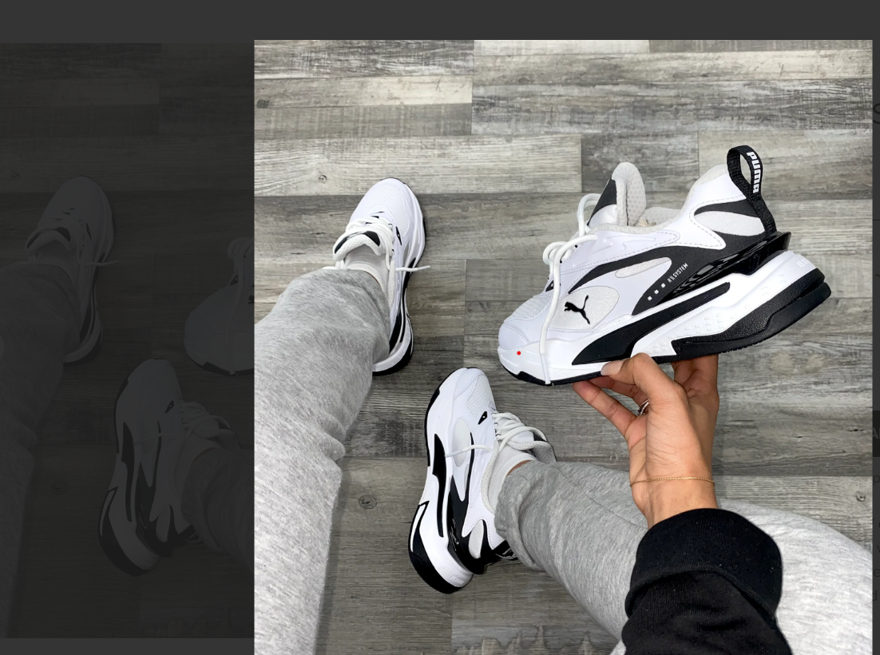

### Project for Python Module

**AIM:**

*The primary aim of this project is to offer exclusive discounts on Puma shoes, enhancing brand visibility, and driving customer engagement. By providing our customers with special access to high-quality Puma footwear at a reduced price, we aim to create a win-win scenario for both parties involved.*

**DESCRIPTIONS:**

Welcome to the Puma shoes Outlet web scrapping project involves extracting data from websites. This data can be used for various purposes,outlet saving are the part of the shopping experience enjoy year-around discounts on preminium product, such as data analysis, research, reporting, or populating databases. We are going to use puma shoes to scrape site. To do so, we are going to use tools like Python, Requests, BeautifulSoup.

**Purposes:**

*The project will involve the promotion and sale of Puma shoes through our platform. We plan to implement a targeted marketing strategy to reach a wide audience and generate interest in the discounted Puma products. Our platform will serve as the central hub for customers to explore the curated selection of Puma shoes and take advantage of the exclusive discounts.*

**Outline:**

*From this site, we are going to grab the following information:*

**steps:**

1. Product Name.
2. Orignal Price.
3. Discounted Price.
4. Discount Price.

**Choose the Website and Webpage URL:**

*The first step is to select the website you want to scrape. We will try to extract data on jewellery on the website.*

### Send a Request to the Puma Shoes Page:

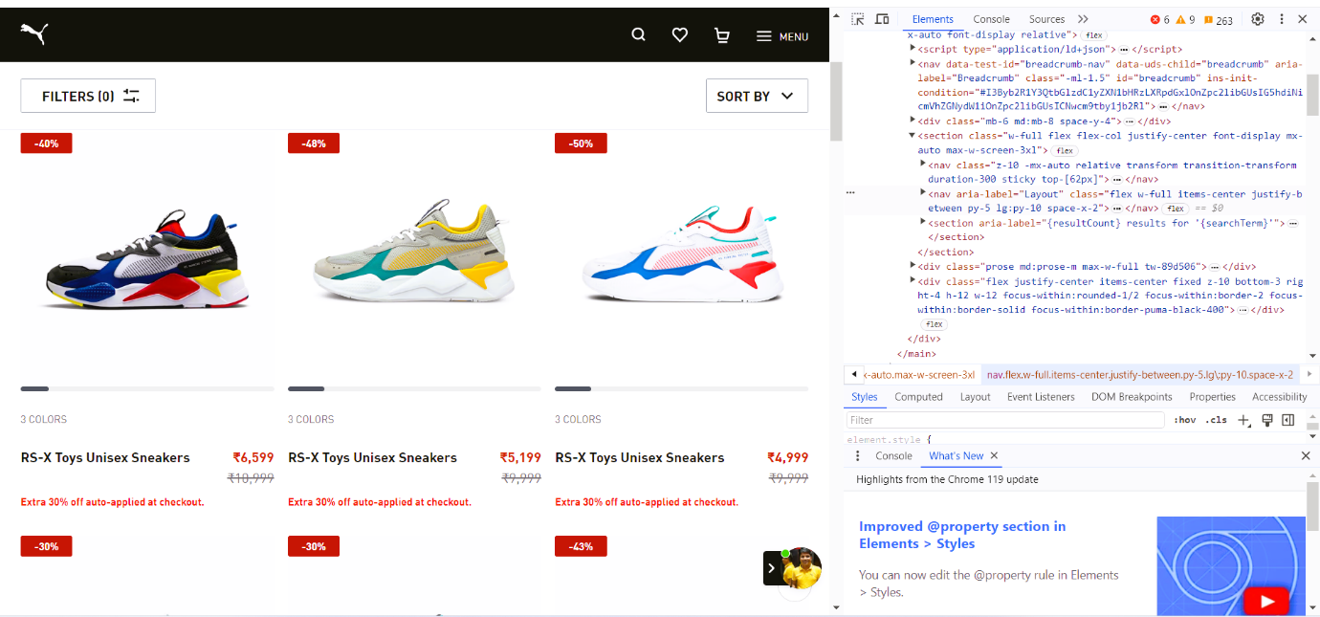

### Write the Python source code:

*The code will perform the following steps:*

* *Using requests to send an HTTP GET requests*
* *Using BeautifulSoup to parse the HTML code*
* *Extracting the required data from the HTML code*
* *Store the information in a pandas dataframe*

### Exporting the extracted data

We’ll export the data as a CSV file. We will use the pandas library. We’ll use the pandas library.

### Puma shoes outlet web scraping codding command steps:

### 

### Beautifying the html code:

### 

### Product name of puma shoes:

### 

### Original price of product:

### 

### Discount price of product:

### 

### Discount percentage of product:

### 

### Converting collected data into tabular format using pandas library:

### 

### Saving the tabulated data into cvs format and opening the file:

### 

### Conclusion:

*As we commemorate the one-year anniversary of Puma Shoes, we extend our sincerest gratitude to our valued customers who have made this journey exceptional. To express our appreciation, we are thrilled to unveil an exclusive anniversary offer—a generous 35 to 50% discount on all Puma shoe purchases. This celebration is not just about a year gone by, but a step forward into many more stylish and comfortable strides together. We invite you to indulge in this limited-time offer as a token of our thanks, making every pair of Puma shoes not just footwear, but a testament to the shared journey of fashion, innovation, and the joy of walking in style. Here's to stepping into the future with you! 🎉👟*

### Thank you…

### 